**Basic Configuration of a Wireless Router**

**Note: Prepare a report, including some screenshots of the tasks you complete.**

The router is a TP-Link TD-W8960N 300Mbps wireless N ADSL2+ router.

The router ships with a default IP address of 192.168.1.1, and a login of username: admin, password: admin.

There is no DHCP pool configured initially, so you can connect through one of the switch ports, assign a static IP address of 192.168.1.10/24 to the PC, and connect to the router configuration by entering 192.168.1.1 into the browser address bar. Log in. You will see something like the following:

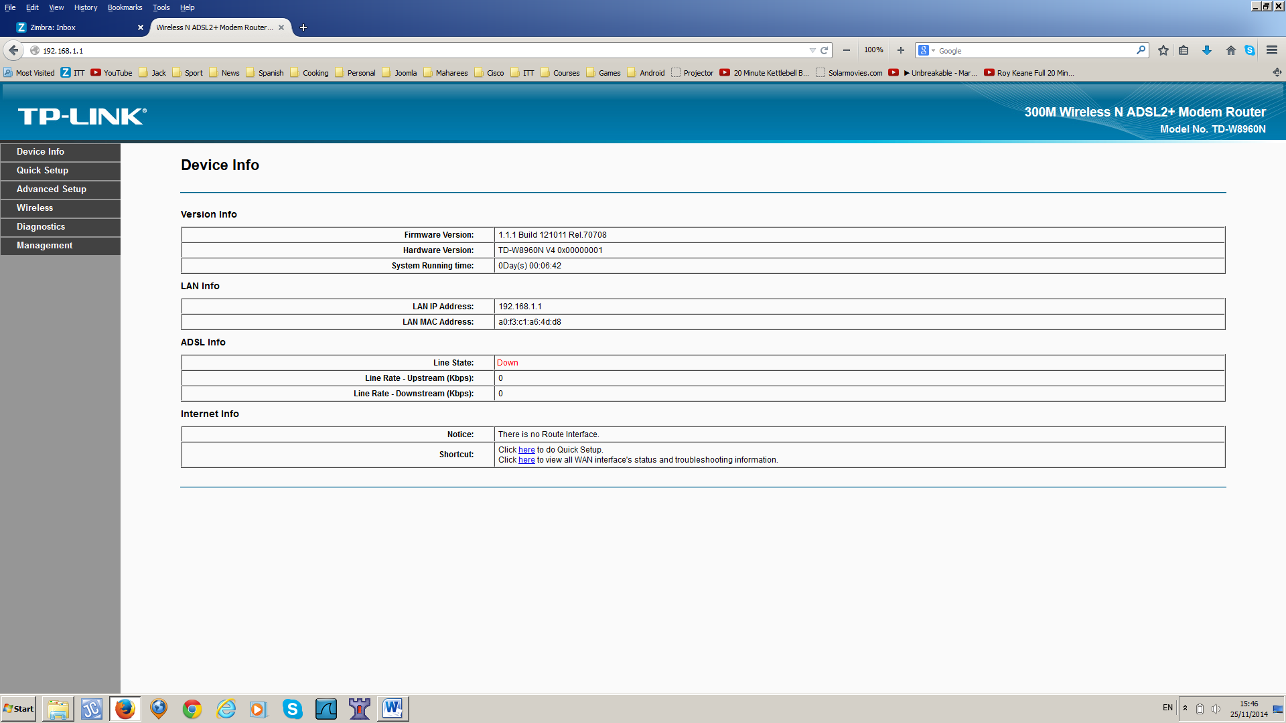

On the left-hand pane, there are menu options. Select the **Quick Setup** option.

You can skip the WAN Configuration, as we don’t have a DSL connection. You will be brought to the wireless configuration where you can enable wireless, change the SSID, and set up the authentication for the network. Choose WPA2-PSK, and choose a password.



**Advanced Setup**

The advanced setup looks as follows:

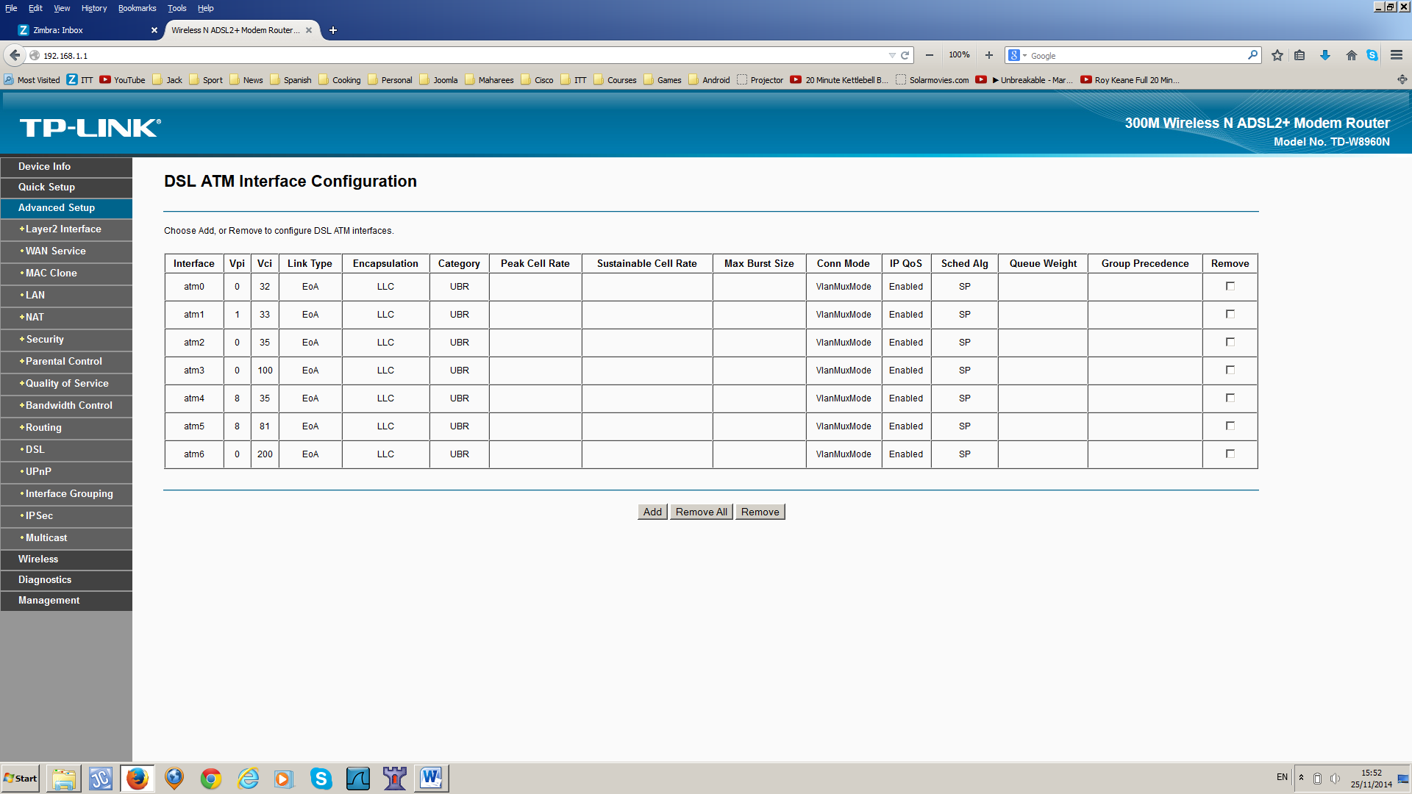

Click on LAN option. Enable DHCP Server, and set up a DHCP pool from 192.168.1.100 to 192.168.1.200.

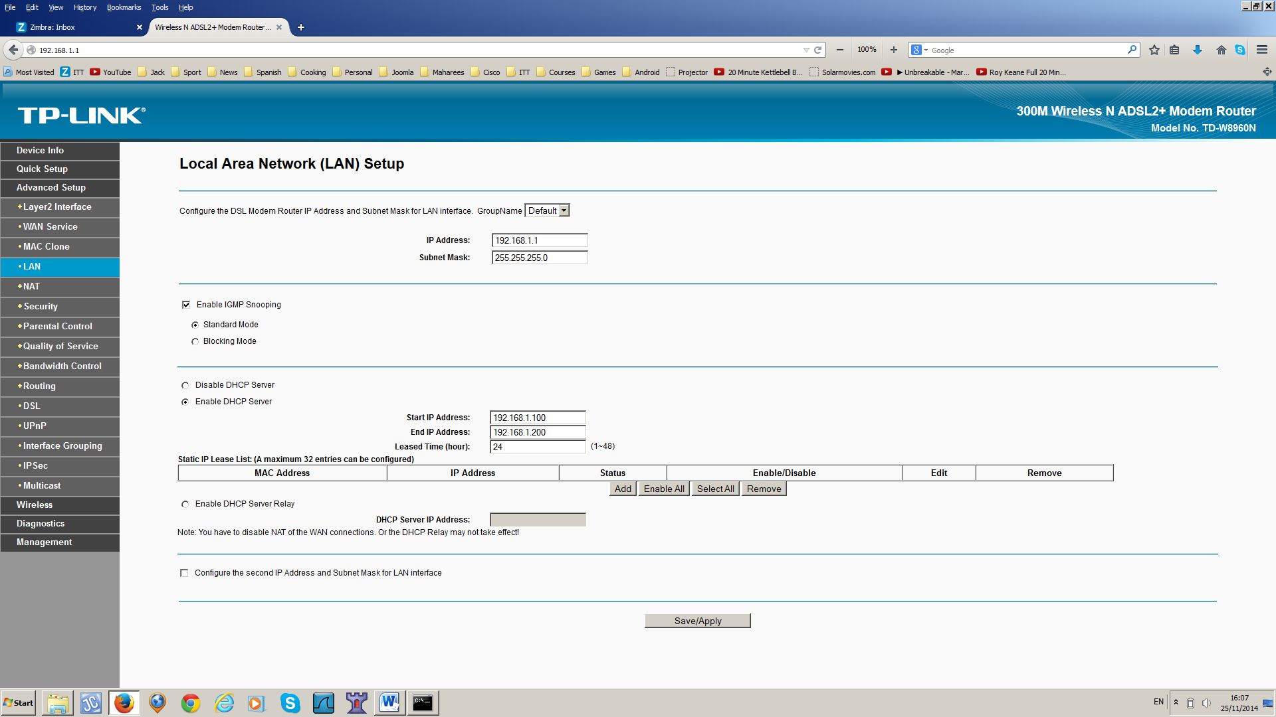

Connect to the wireless network using a laptop/phone.

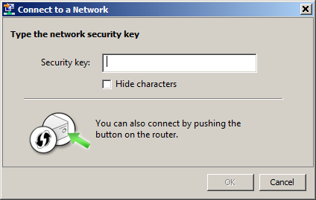

When you have connected, check your IP settings. They should look something like this:

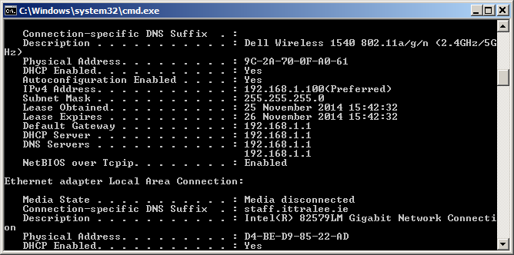

Investigate the different **Security options** on the LAN interface.

Click on the **Wireless option.** You will see something like this:

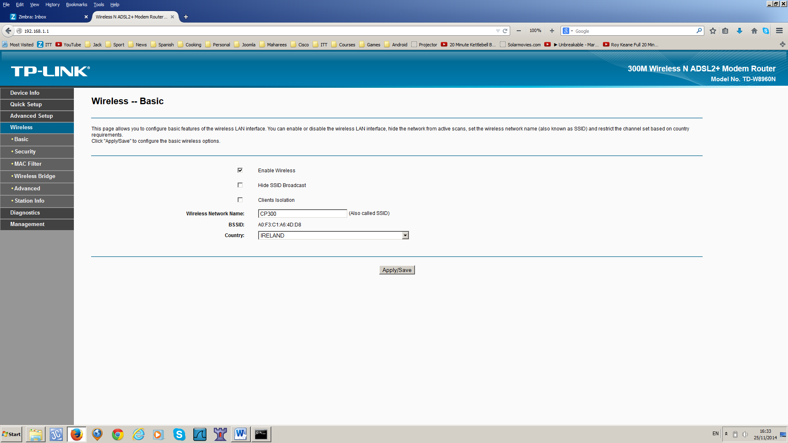

Note how you can **Disable SSID Broadcast.** Test this.

Click on the **Security option and investigate what changes you can make:**

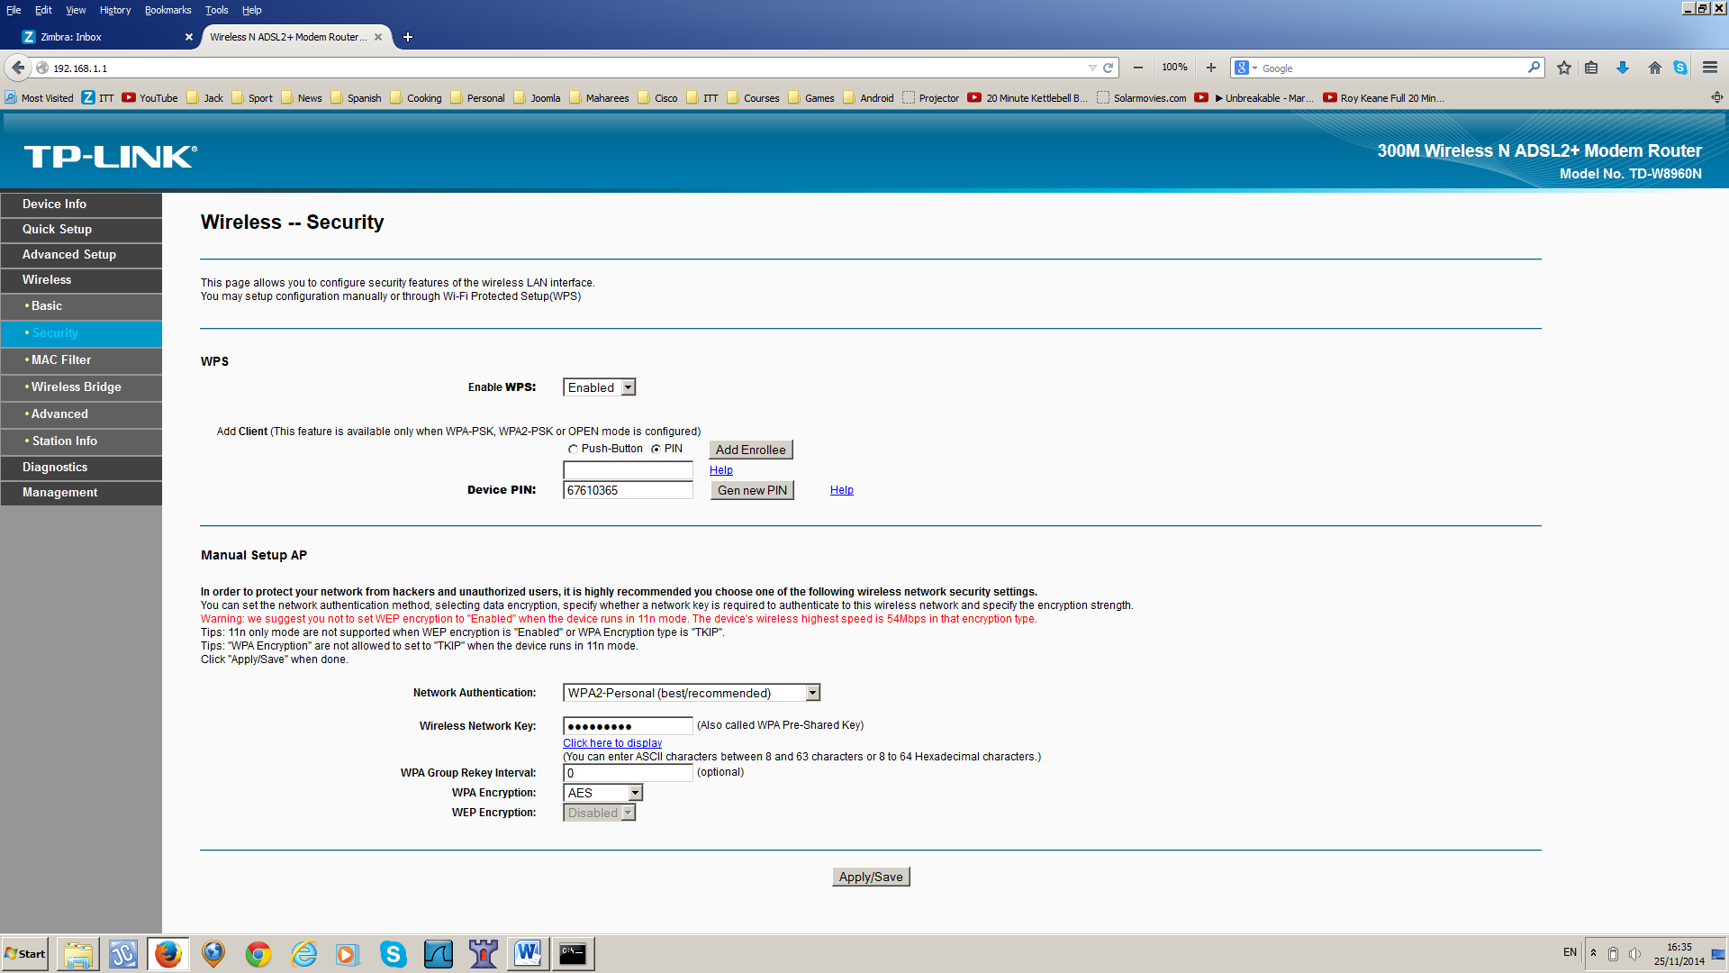

**Note: It is recommended that you disable WPS due to security concerns.**

Setup a **MAC filter** and check that it works:

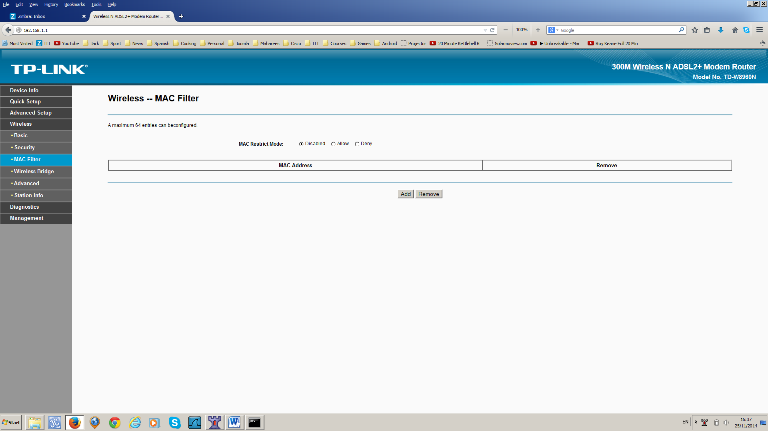

Click on the **Advanced option.** Note that the **Channel is Auto**, by default. See how you can set the channel from 1 – 13 manually.

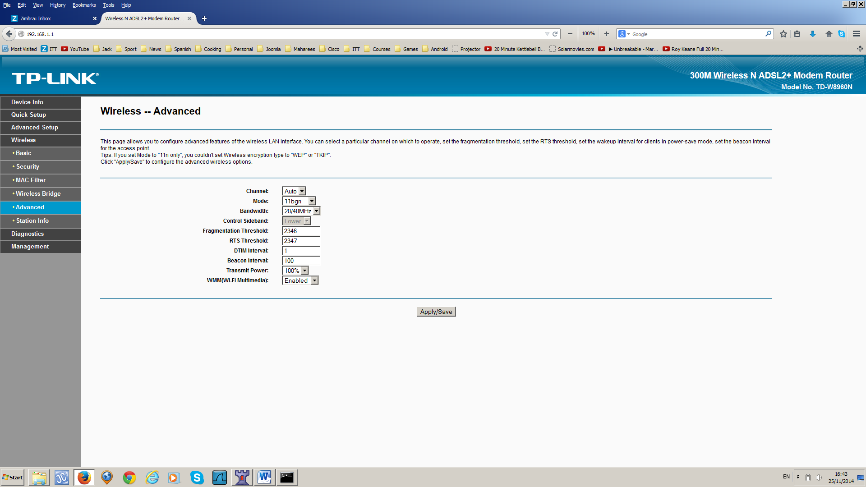

Observe how you can change the **Mode, Bandwidth, and Beacon Interval**.

Have a look at the **Diagnostics and Management options.** Investigate what can be done here.

**Exercise:**

**Prepare a report, including some screenshots of the tasks you completed.**